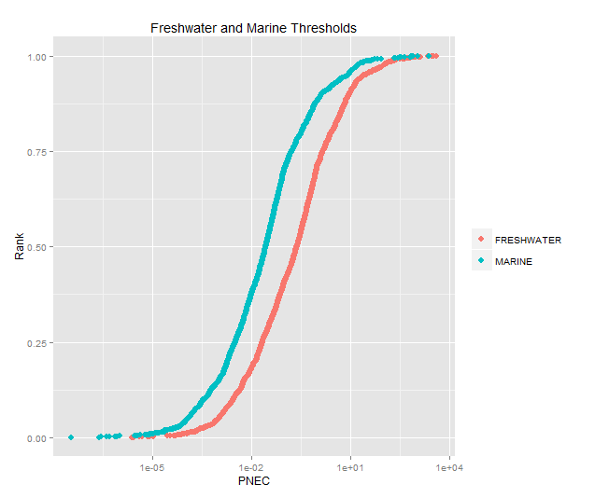

Supporting Figure 1:The cumulative distributions of PNECfreshwater and PNECmarine.for industrial chemicals